**QUIZ USING IF AND ELSE**

OUTPUT IF THE USER ENTERS “yes” TO PLAY

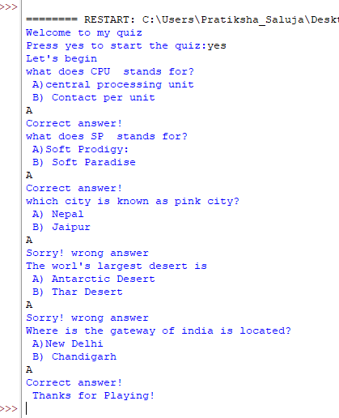

OUTPUT IF THE USER ENTERS “no”

